How to Obtain Medical Records and/or Radiology Images

We offer the following options to obtain a patient’s medical record or radiology images:

Online | Submit a request through our online medical correspondence system. To get started, just select “Medical Records” under the “Patient & Visitors” tab at: www.temeculavalleyhospital.com
Call or In Person | Visit the Centralized Release of Information (ROI) department. Our location and hours are below. You may also reach us by calling (951) 331-2410.
Mail | Mail a written request to: | System Health Information Management Department Attn: Release of Information | Medical Records  25500 Medical Center Drive, Murrieta, CA 92562
Fax | Fax a written request to: | System Health Information Management Department (951) 600-4363
Patient Authorization
Patient information is kept in strict confidence and only released with proper authorization. The authorization is available online or in our office.

Processing Time
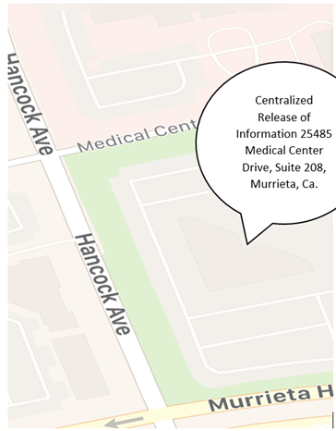
Please be assured we are committed to providing you a copy of your records or imaging study as quickly as possible and the same day if needed. Requests are processed in the order they are received. For urgent needs, please directly contact the ROI department.

Department Hours
The department is open from 8:30 AM to 4:30 PM Monday through Friday, excluding national holidays.

Department Location
The department is located at 25485 Medical Center Drive, Suite 208, Murrieta, CA 92562. It is on the corner of Murrieta Hot Springs Road and Hancock Avenue between Interstate 15 and Interstate 215. Please refer to the map.

Fees for Records
Depending on the purpose of your request, there may be a fee for a copy of the records. You will be advised of any potential fees when your request is submitted and again before it is completed.

Assistance
If you have any questions or would like additional information, please call us at (951) 331-2410, or visit us in-person. Our staff is ready and happy to assist you.

TVH Request Info Form 20210224

